Course Name | ITD 2343 – Object Oriented Programming with C#
Instructor | Mark L. Pranger
Student Name | Eric Christensen
Due date | Sept 29, 2025
Grade | <grade earned here>
Grading Comments | <instructor comments here>

Section 1 exam - Lab

The building of the form will need to be documented with screen shots. There must be at least one screen shot documenting each of the following items.
One screen shot when the initial form is set to its width but without any buttons added
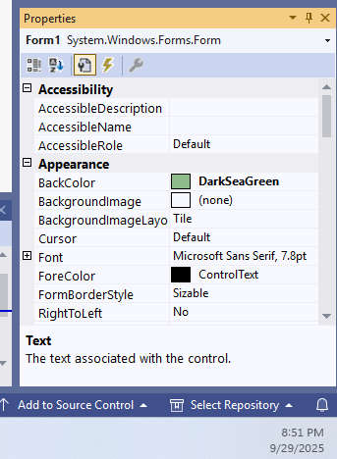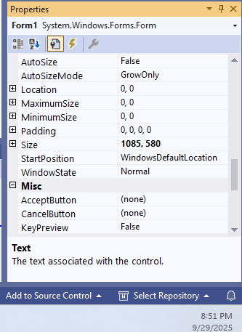
One screen shot after the Letter, Digit, Space, and Period buttons are added
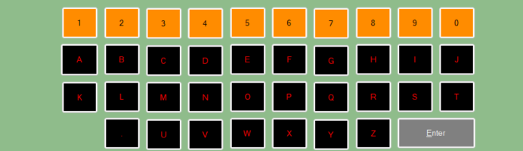

One Screen shot after the Clear and Send buttons are added
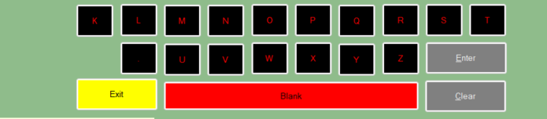

One Screen shot after the Textbox and Label are added
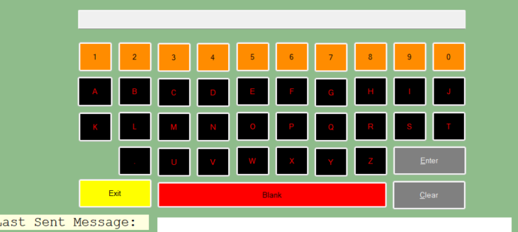

A screen shot of the form when you have completed it still in the IDE (before you run it)
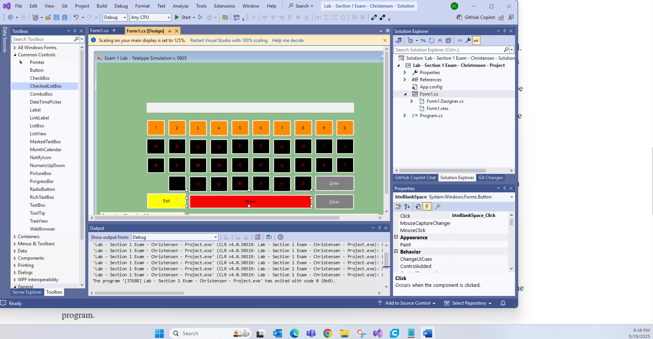
A screen shot of the form while it is running.
This most likely will show the IDE in the background of the screenshot, that is okay.
Screen shots of the form as seen when the program is executed.
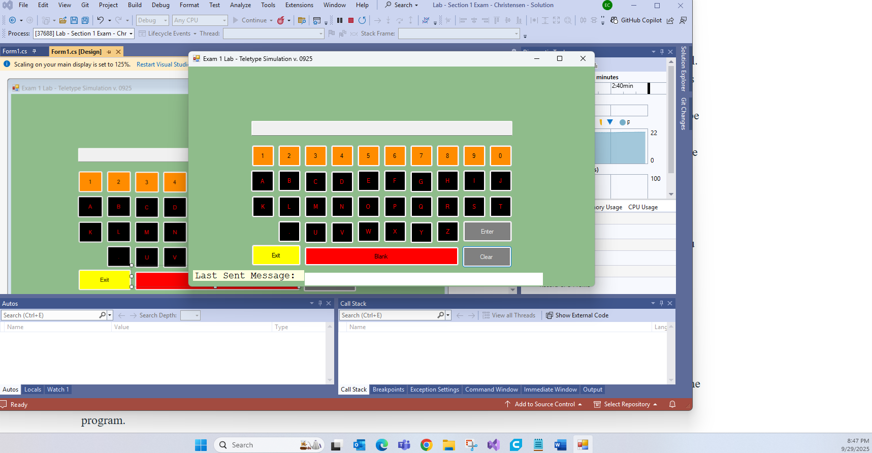
One Screen shot showing a partial message in the textbox and nothing in the last sent label
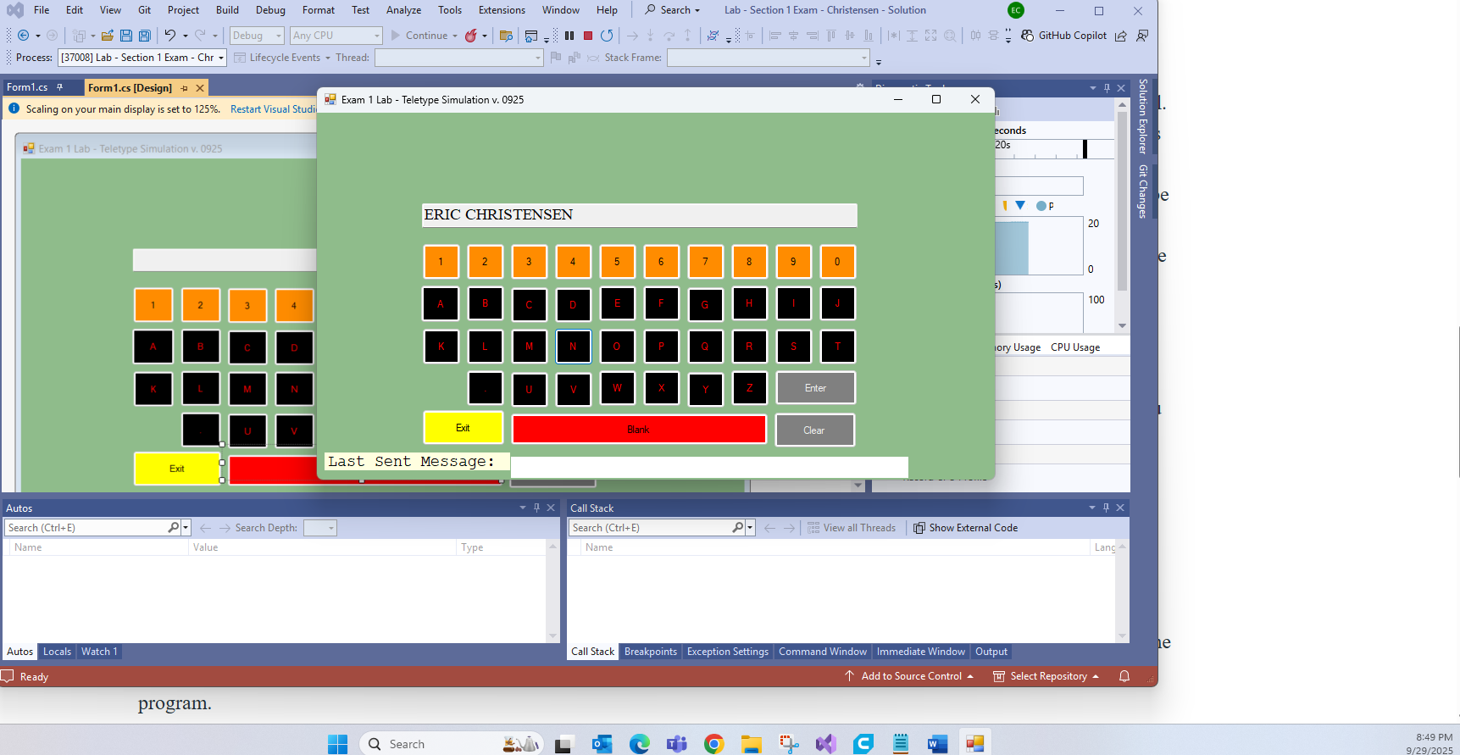
One Screen shot showing completed message in the text box and nothing in the last sent label

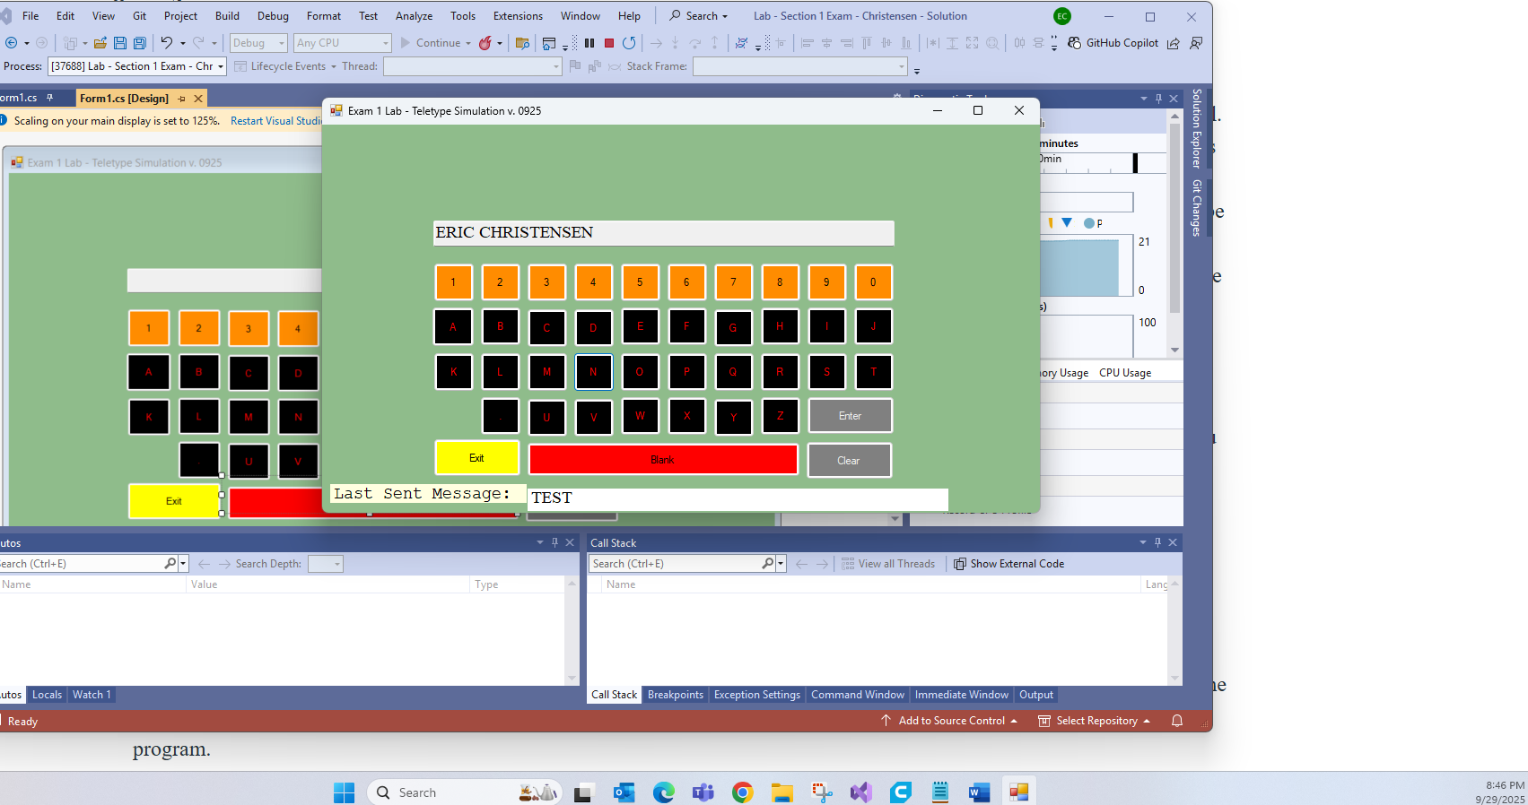
One Screen shot showing the message in the just sent label and the textbox cleared
the form when you interact with it(User Interaction)
